

**PROJECT REPORT**

**Parallel Sudoku Solver**

Course:

* Parallel & Distributed Computing.

Instructor:

* Dr. Hassan Jamil Syed

Group Members:

* Ashmal Anis 19k-0305
* hasnain somani 19k-0204

Objective:

Parallel programming using OpenMP for Parallel and Distributed Computing course. For this purpose, we have developed a serial and a parallel implementation of a solving a Sudoku efficiently in less time.

Methodology:

The grid consists of a matrix of size n x n which is partially filled and the algorithm fills the matrix cells which are blank with values from 1 to n in such a way that no value is repeated more than once on each of n columns and n rows or n squares of size√n × √n on which the matrix is split. & then using dfs for exploration of the grid & for populating the grid.

Output:

Comparison of Serial and Parallel

input: 16*16

Threads: 4

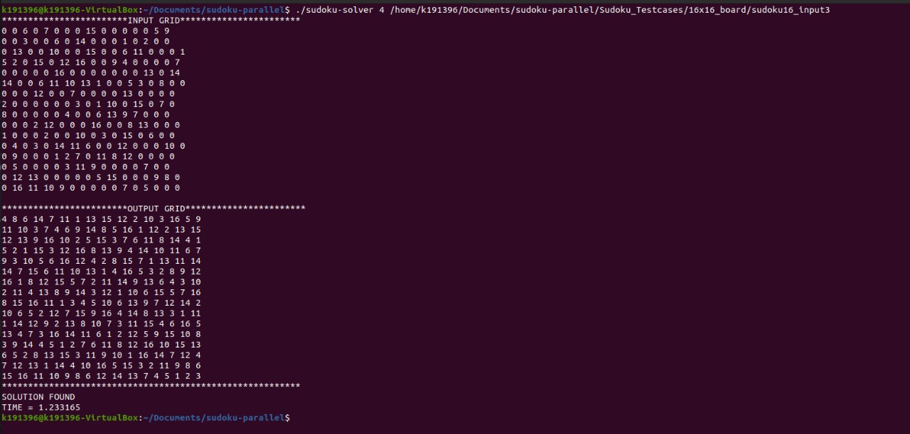

Threads: 2

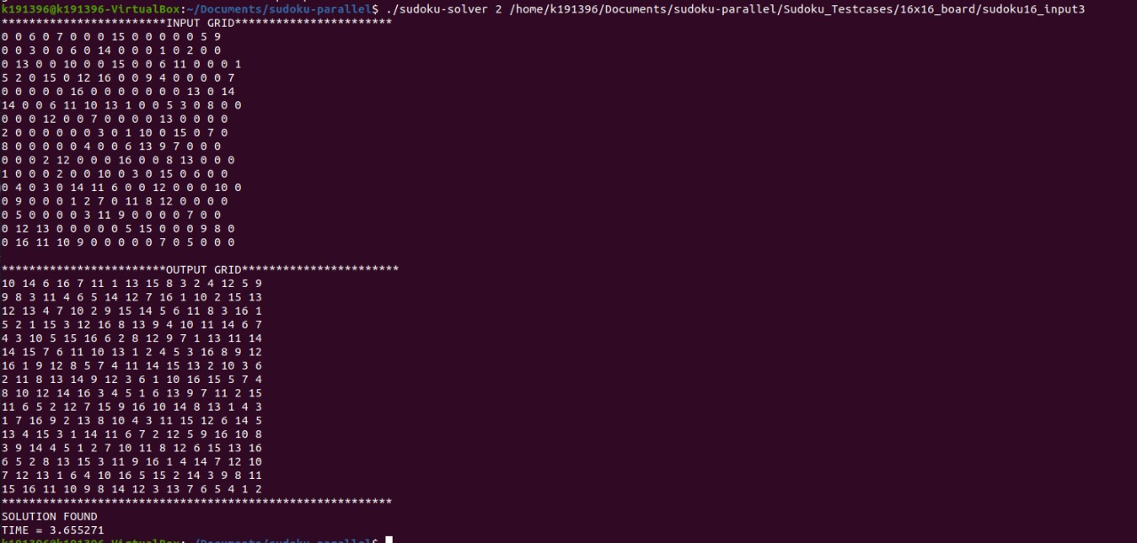

Serial:

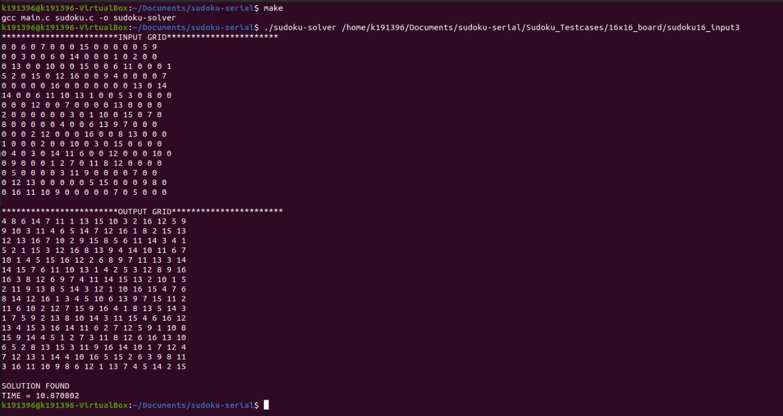

input: 9*9

Threads: 2

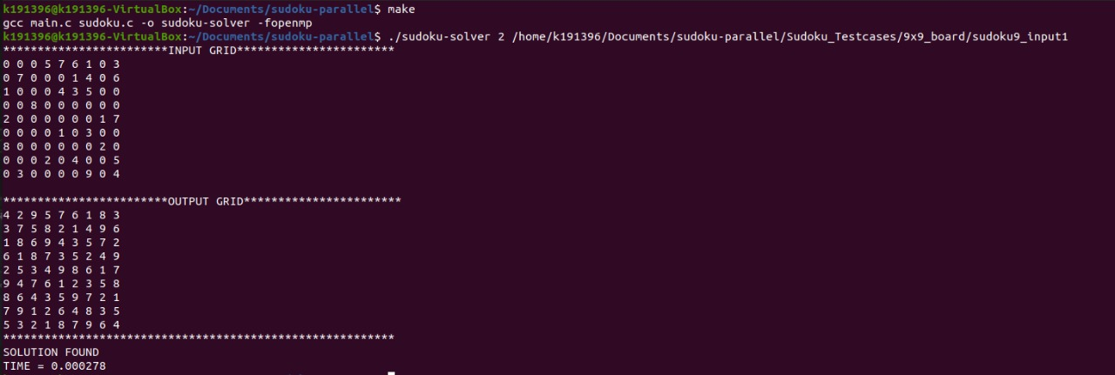

Threads: 1

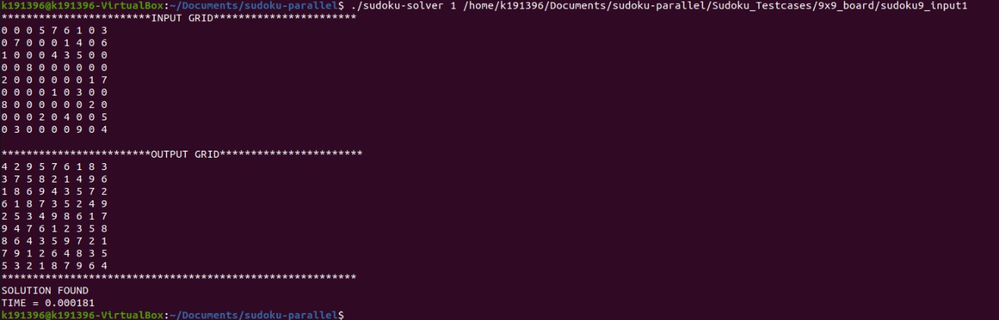

Serial:

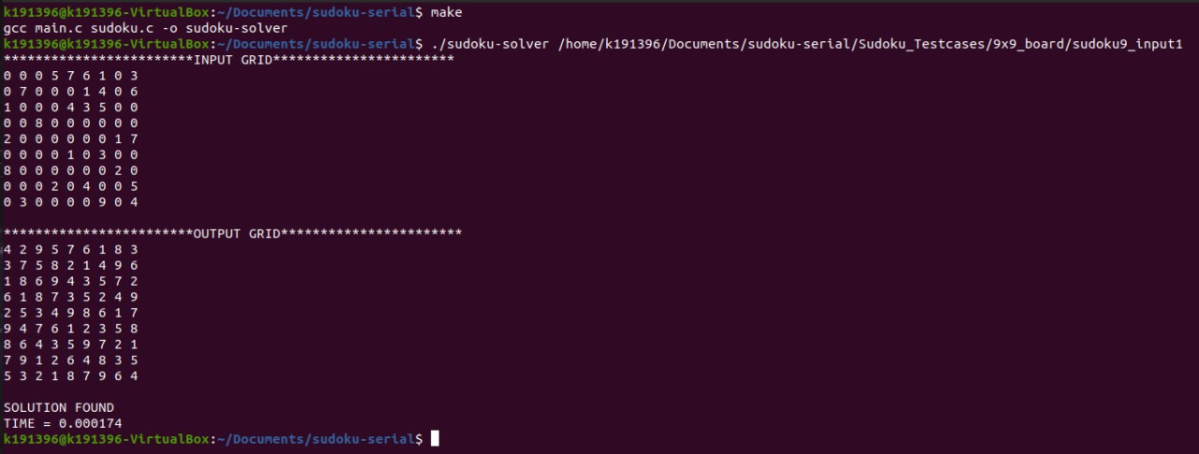

Graph:

Figure 1 : Parallel Execution on N*N Soduku

Figure 2 : Serial Execution on N*N Soduku